THE UNIVERSITY OF DODOMA
COLLEGE OF INFORMATICS AND VIRTUAL EDUCATION

DEPARTMENT OF COMPUTER SCIENCE AND ENGINEERING

GROUP ASSIGNMENT 3
ASSIGNMENT TITLE: PRODUCT RECOMMENDATION SYSTEM
COURSE NAME: SYSTEM ANALYSIS AND DESIGN
COURSE CODE: CP 212
DEGREE PROGRAMM: BSC CS2
GROUP NUMBER: 01
PROGRAMME INSTRUCTOR: DR. CHRISTINA MURO

GROUP MEMBERS
S/N | NAME | REGISTRATION NUMBER
01 | MECKTLIDA MANGASINI KATUNDU | T24-03-17629
02 | BHOKE MARWA MTATIRO | T24-03-14268
03 | MUKSIN ISMAIL BUSHIRI | T24-03-14126
04 | GALANDA JOHN SWEYA | T24-03-10322
05 | SALIM AMIRI SALIM | T24-03-24390
06 | BRIAN SOCRAFI MUNISI | T24-03-10330
07 | INNOCENT CHARLES MKOI | T24-03-26066
08 | JOHN YOHANA CHIBAGO | T24-03-20732
09 | JOHN MLYATU MSHANGI | T24-03-14602
10 | RAYMOND JESTONE MAKUKA | T24-03-14523
Table of Contents
CHAPTER 1: SOFTWARE REQUIREMENTS SPECIFICATION 1
PRODUCT RECOMMENDATION SYSTEM SRS DOCUMENT 1
1.1 Introduction 1
1.1.1 Problem Statement & System Purpose 1
1.1.2 Intended Audience 1
1.1.3 Intended Use 1
1.1.4 Scope 2
1.2 Overall Description 3
1.2.1 Methodology (SDLC) 3
1.2.2 Assumptions & Dependencies 3
1.3 System Features and Requirements 4
1.3.1 Functional Requirements 4
1.3.2 Non-Functional Requirements 4
1.3.3 System Features (High-Level Modules) 5
1.3.4 Data Sources 5
1.4 Planning 5
1.4.1 Cost–Benefit Analysis (TZS) 5
1.4.2 Work Breakdown Structure (WBS) 7
1.4.3 Gantt Chart (32 Working Days) 7
1.4.4 Pert Chart 10
1.4.4 Critical Path 11
CHAPTER 2: STRUCTURED SYSTEMS ANALYSIS AND DESIGN 12
2.1 Data Flow Diagram - Context Diagram 12
2.2 Data Flow Diagram – Level-0 Diagram 12
2.3 Flowchart 13
2.4 Decision Table 14
2.5 Entity Relationship Diagram 14
2.6 Logic Diagrams (any additionals) 15
CHAPTER 3: OBJECT-ORIENTED SYSTEM ANALYSIS AND DESIGN 16
4.1 Use Case Diagram 16
4.2 Use Case Scenario 16
4.3 Activity Diagram 22
4.4 Sequence Diagram 23
Participants 23
Sequence Flow Summary 23
4.5 Class Diagram 25
4.6 Statechart Diagram 29
CHAPTER 4: DESIGN 30
4.1 Architectural Design 30
4.1.1 Architectural Method Used 30
4.1.2 High-Level Architectural Structure 30
4.1.2.1 Presentation Layer (View) 30
4.1.2.2 Application Layer (Controller) 31
4.1.2.3 Business Logic Layer (Model) 31
4.1.2.4 Data Layer (Repository) 31
4.1.2.5 AI Service Layer 31
4.1.2.6 Messaging Layer (Asynchronous Processing) 31
4.1.3 Architectural Benefits 31
4.2 User Interface (UI) 32
4.2.1 Onboarding UI (Registration Forms) 32
4.2.2 Landing Page 35
4.2.3 Search Page 36
4.2.4 Search Results UI 37
4.2.5 Checkout UI 38
4.2.6 Account UI 39
4.2.7 Seller Dashboard UI 40
CHAPTER 5: SYSTEM DEVELOPMENT RESULTS AND DEMONSTRATION 41
System Demonstration 41

CHAPTER 1: SOFTWARE REQUIREMENTS SPECIFICATION

PRODUCT RECOMMENDATION SYSTEM SRS DOCUMENT

Introduction

1.1.1 Problem Statement & System Purpose
In Tanzania, online buying is fragmented: product discovery is messy, seller catalogs are inconsistent, and users waste time bouncing between WhatsApp, Instagram pages, and random shops.
Hweibo solves this by providing:
- A marketplace where sellers list products and customers browse/search
- An AI-powered recommendation system that suggests products from the platform catalog
- A clean flow for purchase and pickup/delivery selection
- A clear revenue model: commissions, seller subscriptions, delivery-fee margin
Purpose: Help users find relevant products faster (especially via prompt-based search), while enabling sellers to manage listings and fulfill orders efficiently.

1.1.2 Intended Audience
- Customers: browse, search, purchase, track orders
- Sellers/Suppliers: list products, manage inventory, receive orders
- Admins: manage categories, moderate listings, manage fees and commissions
- Developers/Assessors: review the prototype and SRS

1.1.3 Intended Use
- A user registers (as customer or seller) and can still shop either way
- UI has only two main tabs: Browse and Search
- Search supports:
  - Prompt mode: user describes what they want → system returns 5 ranked products with images
  - Name mode: user types product name → standard search results
- Checkout includes:
  - pickup vs delivery (delivery only if seller/package supports it)
  - delivery fee is added to total when delivery chosen

1.1.4 Scope
In scope
- User registration/login and role selection (customer or seller)
- Seller onboarding (sole seller or company)
- Product listing and product images
- Browse or search UI
- AI recommendation and ranking
- Orders and payment status (prototype can simulate payment)
- Delivery choice logic and fees
- Commission/subscription fee tracking (billing can be simulated)
Out of scope (prototype limitations)
- Real payment gateway integration (can be mocked)
- Full delivery partner integration (kept minimal as requested)
- Advanced fraud prevention

Term | Meaning
SRS | Software Requirements Specification
SSAD | Structured Systems Analysis and Design
OOSAD | Object-Oriented Systems Analysis and Design
DFD | Data Flow Diagram
ERD | Entity Relationship Diagram
NPV | Net Present Value
ROI | Return on Investment
BEP | Break Even Point
TZS | Tanzanian Shilling
Gemini-3 API | LLM used for recommendation ranking and prompt understanding

1.2 Overall Description

1.2.1 Methodology (SDLC)
We adopt Agile Scrum because:
- Requirements will evolve once users test “prompt search”
- Prototype delivery is required (Scrum supports incremental releases)
- Continuous feedback improves usability and recommendation quality

1.2.2 Assumptions & Dependencies
Assumptions
- Sellers provide accurate product data (price, stock, delivery availability)
- Users have stable internet access for image-heavy browsing
- For prototype: payments can be “Pending/Completed” without actual gateway
Dependencies
- PostgreSQL database availability
- Gemini-3 API availability and quota
- Object storage or local storage for product images (prototype can store locally)

1.3 System Features and Requirements

1.3.1 Functional Requirements
ID | Requirement
FR-01 | Users shall register as Customer or Seller (company/sole seller).
FR-02 | Sellers shall create/update/delete product listings with images.
FR-03 | Customers shall browse products by categories and filters (price, rating, delivery).
FR-04 | Search shall support prompt-based search and name-based search.
FR-05 | Prompt-based search shall return exactly 5 ranked products with images
FR-06 | Users shall add products to cart and place orders.
FR-07 | System shall enforce delivery logic: delivery only if selected package supports delivery.
FR-08 | System shall compute totals in TZS including delivery fee where applicable.
FR-09 | System shall record commissions per order and seller subscription status.
FR-10 | System shall store user interactions (views/likes/purchases) for recommendations.
FR-11 | Sellers shall view orders and update fulfillment status (Ready for pickup / Shipped).
FR-12 | Admin shall moderate products, categories, and seller subscriptions (prototype-level).

1.3.2 Non-Functional Requirements
Category | Requirement
Performance | Search results should load under 2 seconds for typical loads (prototype target).
Reliability | System should recover gracefully from Gemini API failures (fallback to keyword search).
Security | Passwords hashed, role-based access control (RBAC), input validation.
Usability | Mobile-first UI; only Browse and Search as main navigation.
Maintainability | Modular TypeScript codebase; API versioning; logs for key actions
Availability | Target 99% uptime for production concept (prototype is local).
Privacy | Store only necessary user data; protect order and contact info

1.3.3 System Features (High-Level Modules)
- Authentication & Role Management
- Seller Store Management
- Product Catalog (images and inventory)
- Browse Experience
- Search (Name and Prompt)
- Recommendation Engine (Gemini-assisted ranking)
- Orders and Delivery Selection
- Billing & Revenue Tracking (commission and subscription and delivery margin)
- Admin Tools (moderation, categories)

1.3.4 Data Sources
- Primary (internal)
  - Seller-uploaded product data (name, price, stock, tags, delivery availability)
  - User behavior logs (views, cart adds, likes, purchases)
  - Order history and ratings
- Secondary (optional for enhancement)
  - Public datasets for product categories/taxonomy (non-copyright, open)
  - Supplier “bulk uploads” via CSV to seed inventory (prototype-friendly)

1.4 Planning

1.4.1 Cost–Benefit Analysis (TZS)
A) Estimated Costs
Initial (Year 0)
- Development effort, equipment, initial hosting setup, initial marketing
- Total initial investment = 35,000,000 TZS
Operational Costs (embedded inside net cashflows below)
- Hosting, DB, storage, support, API usage, moderation

B) Estimated Net Cash Inflows (after operating costs)
Assume revenue grows as sellers and orders increase.
YEAR | Net Cashflow (Tzsh)
0 | -35,000,000
1 | 10,000,000
2 | 16,000,000
3 | 22,000,000
4 | 27,000,000
5 | 32,000,000

C) Discount Rates (falling rates approximation)
Using a declining discount rate schedule (as you requested):
- Year 1: 12%
- Year 2: 11%
- Year 3: 10%
- Year 4: 9%
- Year 5: 8%
D) NPV (Net Present Value
Year | Cashflow | Discount Factor (cumulative) | Present Value
0 | -35,000,000 | 1.0000 | -35,000,000
1 | 10,000,000 | 1.1200 | 8,928,571
2 | 16,000,000 | 1.2432 | 12,870,013
3 | 22,000,000 | 1.3675 | 16,087,516
4 | 27,000,000 | 1.4906 | 18,113,550
5 | 32,000,000 | 1.6098 | 19,877,696

NPV = 40,877,346 TZS (positive) → financially viable under these assumptions.

E) ROI (Return on Investment)
ROI over 5 years (simple, undiscounted):
- Total inflows = 107,000,000 TZS
- Net profit = 107,000,000 − 35,000,000 = 72,000,000 TZS
ROI = 72,000,000 / 35,000,000 = 2.057 = 205.7%
F) BEP (Break Even Point / Payback)
Cumulative cashflows:
- End of Year 1: -25,000,000
- End of Year 2: -9,000,000
- Year 3 adds 22,000,000 → crosses zero
Payback fraction in Year 3: 9,000,000 / 22,000,000 = 0.409 years
BEP ≈ 2.41 years ≈ 2 years 5 months

1.4.2 Work Breakdown Structure (WBS)
Task No | Task Description | Duration (Days) | Predecessor(s)
1 | Project initiation & requirements analysis | 5 | _
2 | UI/UX design (wireframes & mockups) | 4 | 1
3 | Database design (ERD & schema) | 3 | 1
4 | Backend API development (Bun + TypeScript) | 8 | 3
5 | Frontend development (Vite.js UI) | 8 | 2, 4
6 | AI recommendation integration (Gemini-3 API) | 6 | 4
7 | System integration & testing | 5 | 5, 6
8 | Deployment & system demonstration | 3 | 7

1.4.3 Gantt Chart (32 Working Days)
Task No | Task Description | Start Day | End Day | Duration(days)
1 | Project initiation & requirements analysis | 1 | 5 | 5
2 | UI/UX design (wireframes & mockups) | 6 | 9 | 4
3 | Database design (ERD & schema) | 6 | 8 | 3
4 | Backend API development (Bun + TypeScript) | 9 | 16 | 8
5 | Frontend development (Vite.js UI) | 17 | 24 | 8
6 | AI recommendation integration (Gemini-3 API) | 17 | 22 | 6
7 | System integration & testing | 25 | 29 | 5
8 | Deployment & system demonstration | 30 | 32 | 3

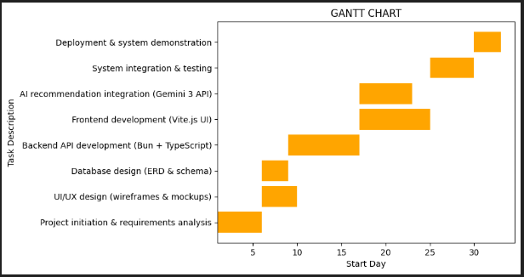

1.4.4 Pert Chart
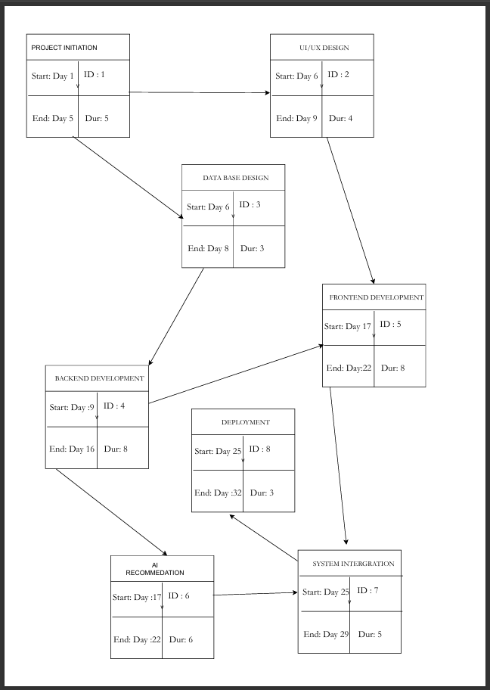

1.4.4 Critical Path
Path 1:
Project Initiation → UI/UX → Frontend → System Integration → Deployment
= 5 + 4 + 8 + 5 + 3
= 25 days
Path 2:
Project Initiation → Database → Backend → Frontend → System Integration → Deployment
= 5 + 3 + 8 + 8 + 5 + 3
= 32 days
Path 3:
Project Initiation → Database → Backend → AI → System Integration → Deployment
= 5 + 3 + 8 + 6 + 5 + 3
= 30 days
The critical path is 32 days.

CHAPTER 2: STRUCTURED SYSTEMS ANALYSIS AND DESIGN

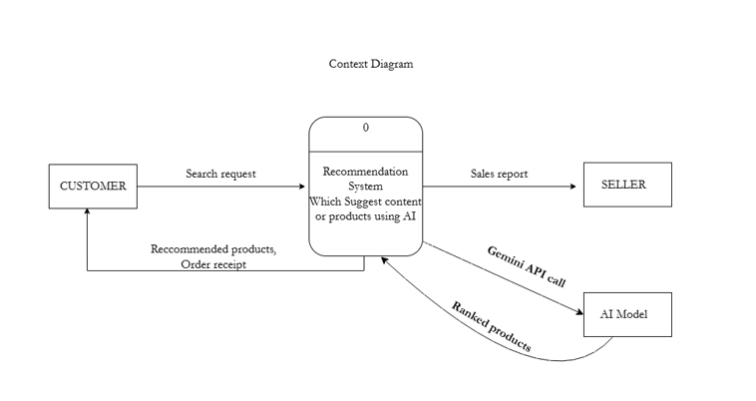
2.1 Data Flow Diagram - Context Diagram

2.2 Data Flow Diagram – Level-0 Diagram
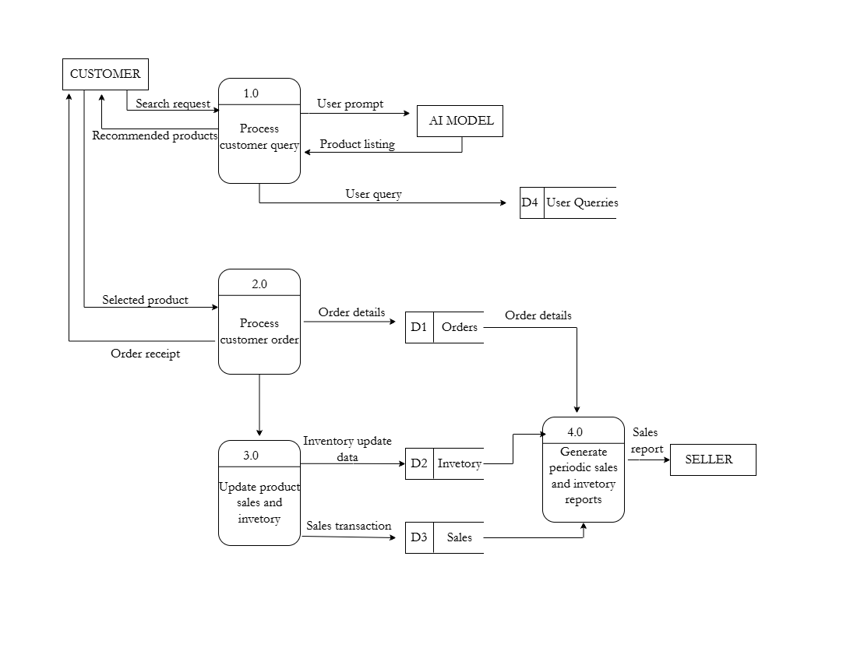

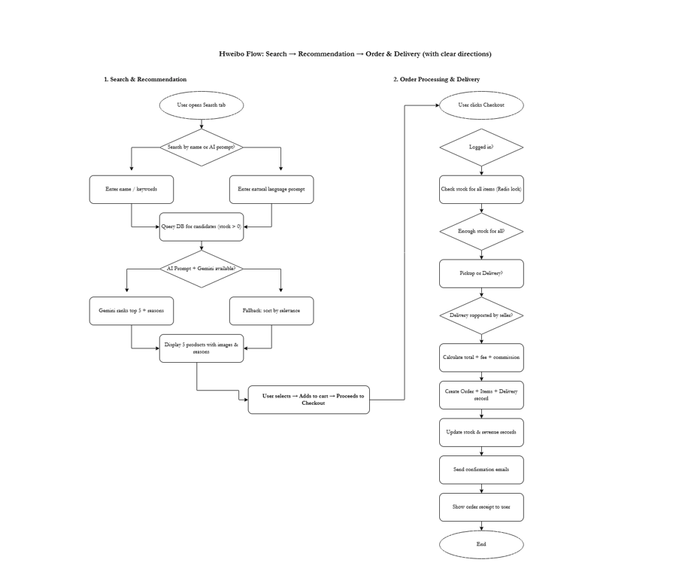
2.3 Flowchart

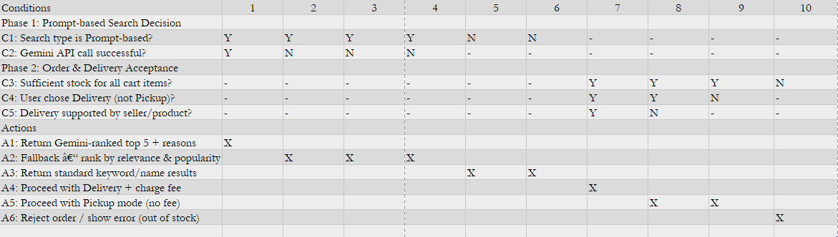
2.4 Decision Table

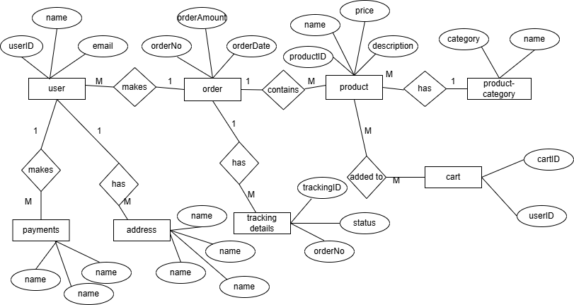
2.5 Entity Relationship Diagram

2.6 Logic Diagrams (any additionals)
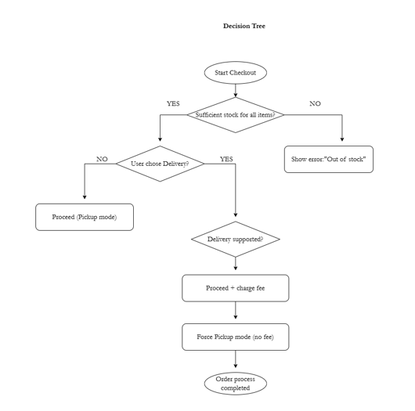
- Decision tree
- Structured English
IF sufficient stock for all cart items THEN
IF user selected Delivery mode THEN
IF seller supports delivery for all selected products THEN
Add delivery fee
Proceed with delivery order
ELSE
Force Pickup mode (no delivery fee)
Proceed with pickup order
ENDIF
ELSE
Proceed with pickup order
ENDIF
ELSE
Display error: "Insufficient stock – order cannot proceed"
ENDIF

CHAPTER 3: OBJECT-ORIENTED SYSTEM ANALYSIS AND DESIGN
Tool use: Draw.io

4.1 Use Case Diagram
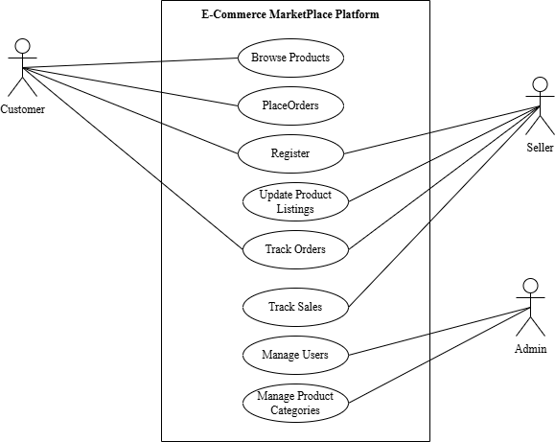

4.2 Use Case Scenario
Use Case Scenario 01: Browse Products
Use Case | Browse Products
Primary Actor | Customer
Preconditions | Platform is accessible; products exist in the catalog
Postconditions | Customer views products with images, prices, descriptions
Trigger | Customer navigates to homepage, category, or uses search
Basic Flow | 1. Open products section or homepage  2. System displays product list  3. Apply filters, search, or sort  4. View matching results  5. Click to see product details
Alternative Flows | AI model displays personalized recommendations automatically
Exception Flows | No matching products → Display 'No products found' message with suggestions
Assumptions | Product data is up-to-date

Use Case Scenario 02: Place Order
Use Case Scenario | Place Order
Primary Actor | Customer
Preconditions | Customer is logged in; shopping cart contains items with sufficient stock
Postconditions | Order is created; stock reduced; confirmation email sent; seller notified
Trigger | Customer clicks 'Proceed to Checkout' from cart
Basic Flow | 1. Review cart contents
2. Enter delivery address and payment method
3. Review final summary
4. Confirm order
5. Process payment
6. Create order record and update inventory
7. Send confirmation and notify seller
8. Display success page with order ID
Alternative Flows | A1: Apply discount coupon  A2: Select from saved addresses
Exception Flows | E1: Insufficient stock  E2: Payment fails → retry
Assumptions | Payment gateway integration is reliable

Use Case Scenario 03: Register
Use Case Scenario | Register
Primary Actor | Customer or Seller
Preconditions | User is not yet registered
Postconditions | New account created and verified; user can log in
Trigger | User clicks Register or Sign Up
Basic Flow | 1. Select role if required  2. Enter email, password, name  3. Accept terms  4. System validates input  5. Send verification email  6. User clicks verification link  7. Account activated
Exception Flows | Duplicate email or weak password
Assumptions | Email service is functioning

Use Case Scenario 05: Track Orders
Use Case Scenario | Track Orders
Primary Actor | Customer
Preconditions | Customer is logged in and has orders
Postconditions | Customer views order history and status
Trigger | Customer selects My Orders
Basic Flow | 1. Display list  2. Select order  3. Show details and tracking
Exception Flows | No orders exist
Assumptions | Status updates are real-time

Use Case Scenario 06: Track Sales
Use Case Scenario | Track Sales
Primary Actor | Seller
Preconditions | Seller is logged in and has sales
Postconditions | Seller views sales reports
Trigger | Seller opens Sales Dashboard
Basic Flow | 1. Show overview  2. Apply filters  3. View detailed records
Exception Flows | No sales in period
Assumptions | Sales data is accurate

Use Case Scenario 07: Manage Users
Use Case Scenario | Manage Users
Primary Actor | Admin
Preconditions | Admin logged in with privileges
Postconditions | User records updated
Trigger | Admin opens User Management
Basic Flow | 1. Search user  2. Select  3. Perform action  4. Save
Exception Flows | Permission denied or user not found
Assumptions | Admin has full access

Use Case Scenario 08: Manage Product Categories
Use Case Scenario | Product Categories
Primary Actor | Admin
Preconditions | Admin logged in
Postconditions | Categories updated
Trigger | Admin accesses Categories
Basic Flow | 1. View categories  2. Add/edit/delete  3. Assign products  4. Save
Exception Flows | Duplicate name
Assumptions | Improves organization

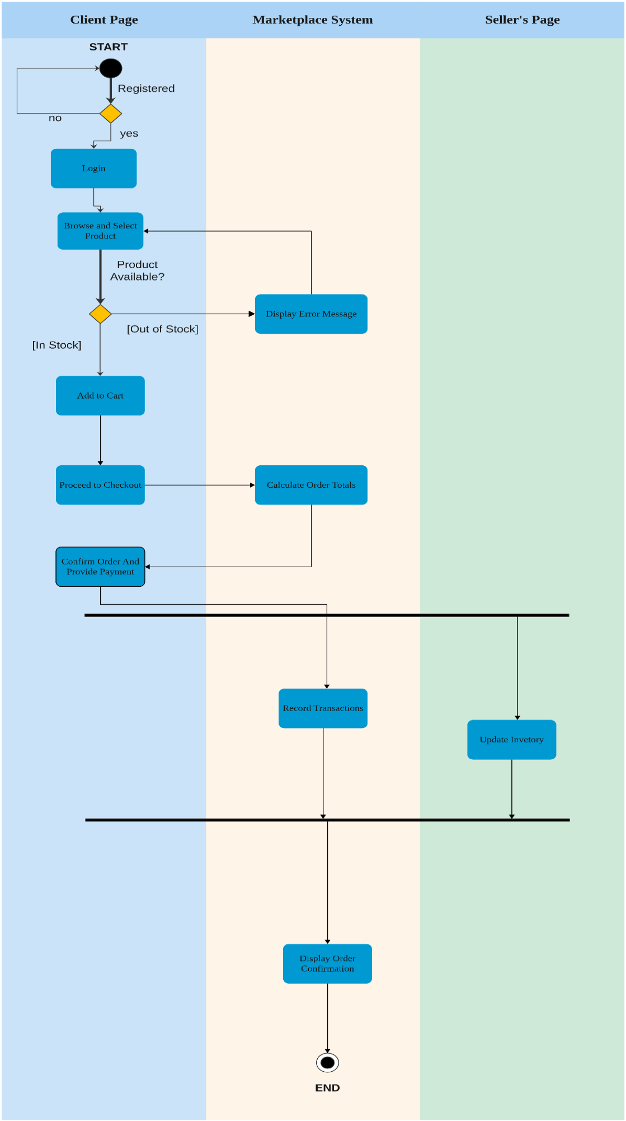
4.3 Activity Diagram

4.4 Sequence Diagram
This sequence diagram presents a simplified e-commerce checkout process using domain-driven design (DDD). It highlights how three core business objects interact during a customer's purchase journey.

Participants
Customer: Initiates checkout, provides payment details, and receives notifications.
Order: Central entity that coordinates validation, calculations, status updates, and workflow.
Product: Manages inventory data and confirms stock availability.

Sequence Flow Summary
1. Checkout Initiation: Customer starts checkout using checkout().
2. Stock Validation: Order verifies availability via stockAvailable().
3. Stock Response: Product returns availability status.
4. Fee Calculation: Order internally calculates subtotal, tax, shipping, and discounts.
5. Payment Submission: Customer submits payment using payOrder().
6. Status Update: Order updates internal status using getStatus().
7. Notification: Order sends deliveryNotification() to the customer.
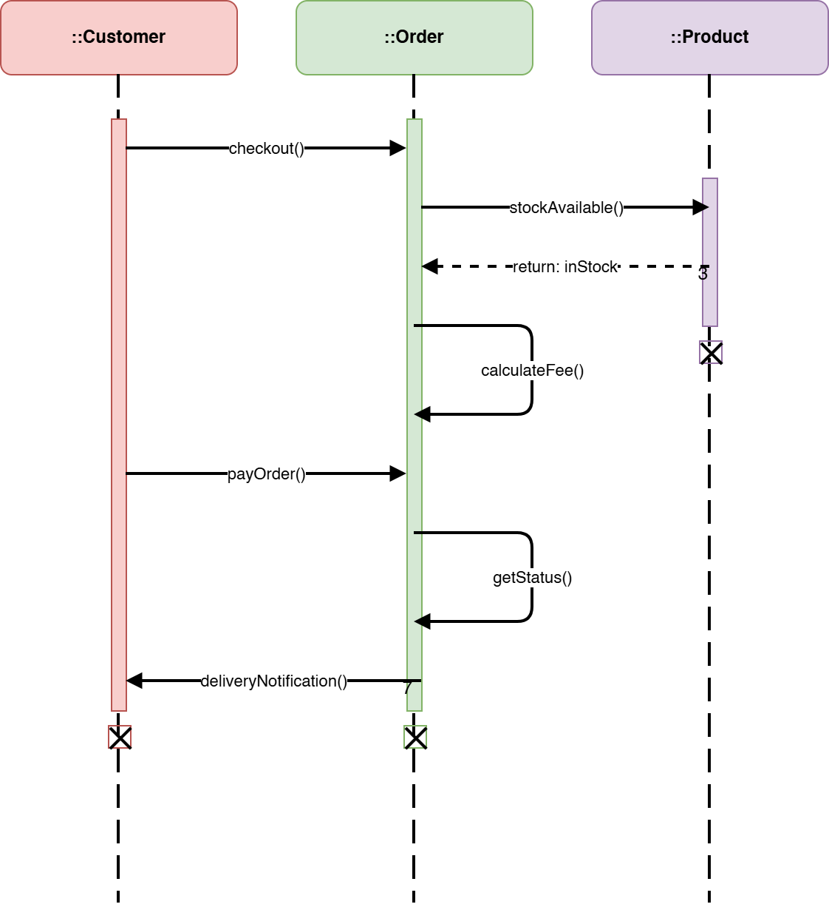

4.5 Class Diagram
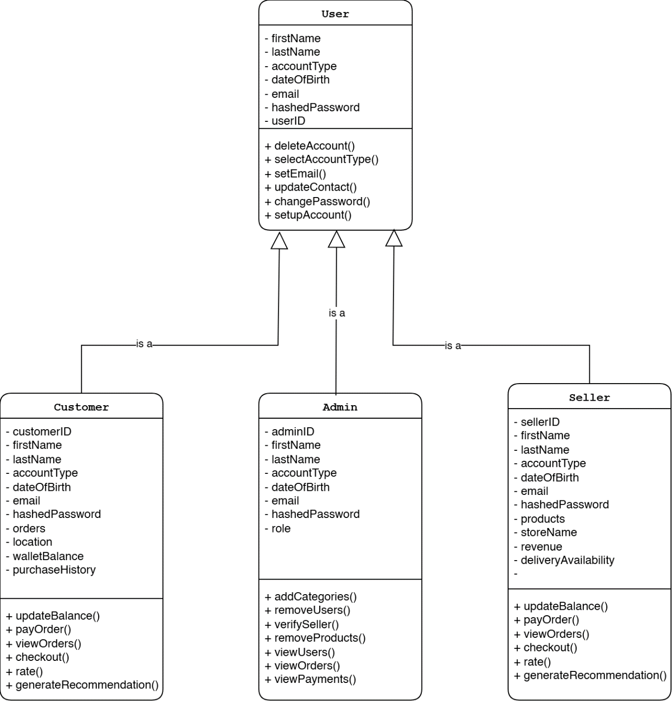
The following are the classes for the Product Recommendation System

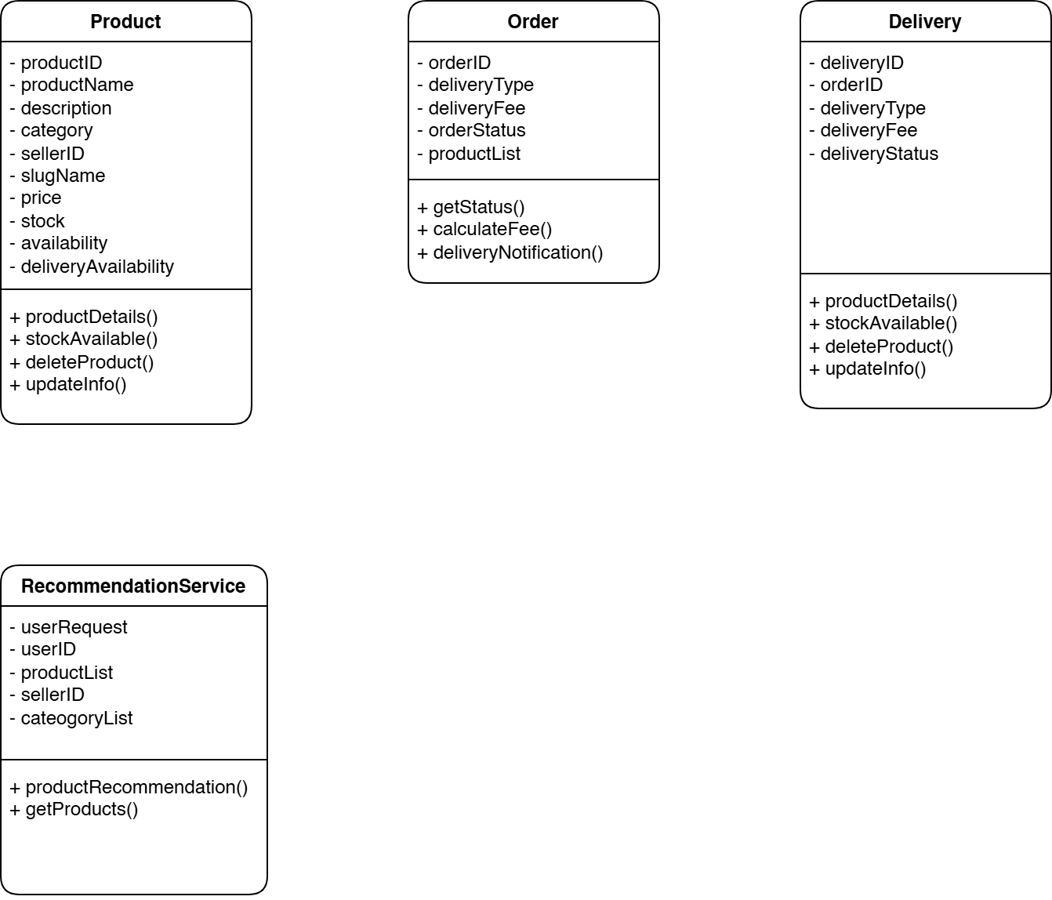

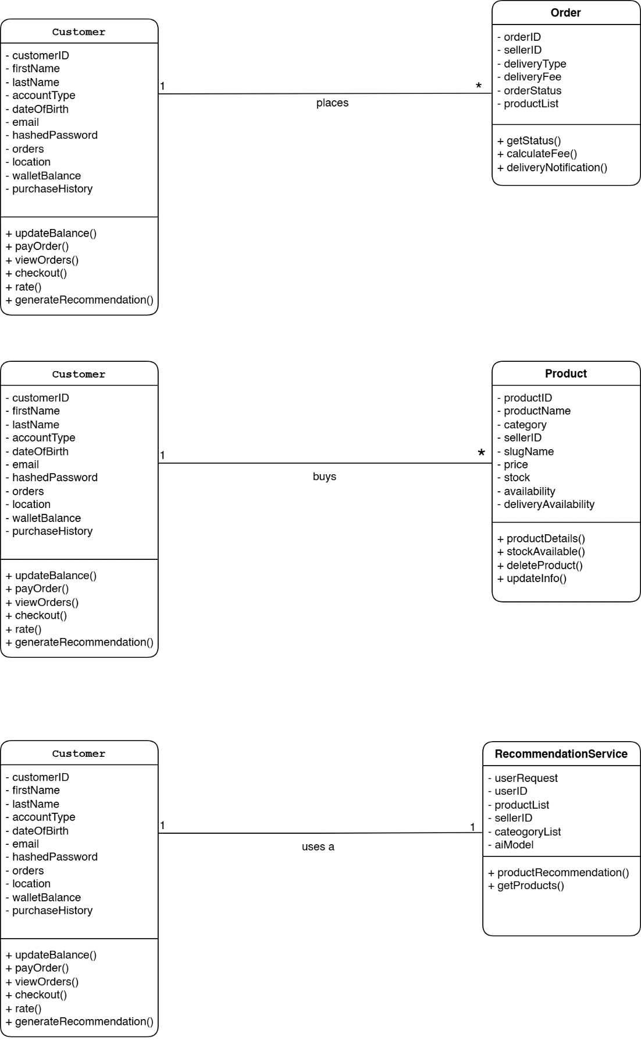
Class Relationships
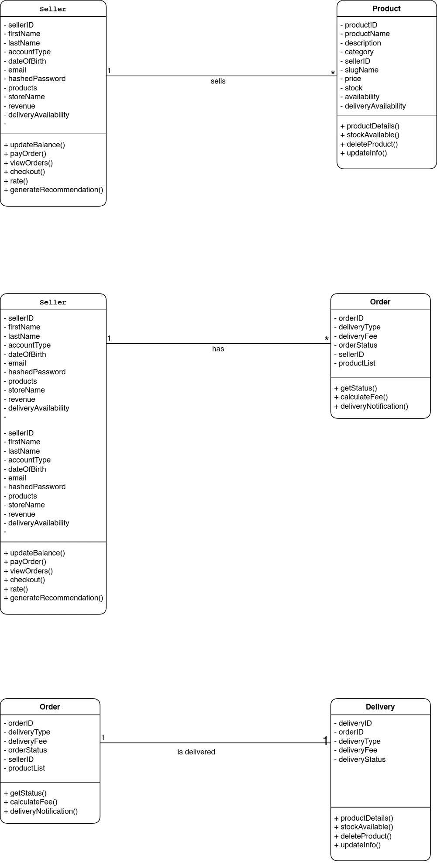

4.6 Statechart Diagram
The following is the state chart diagram of a Customer’s Order, which changes as the order is processed through various processes.

CHAPTER 4: DESIGN

4.1 Architectural Design

4.1.1 Architectural Method Used
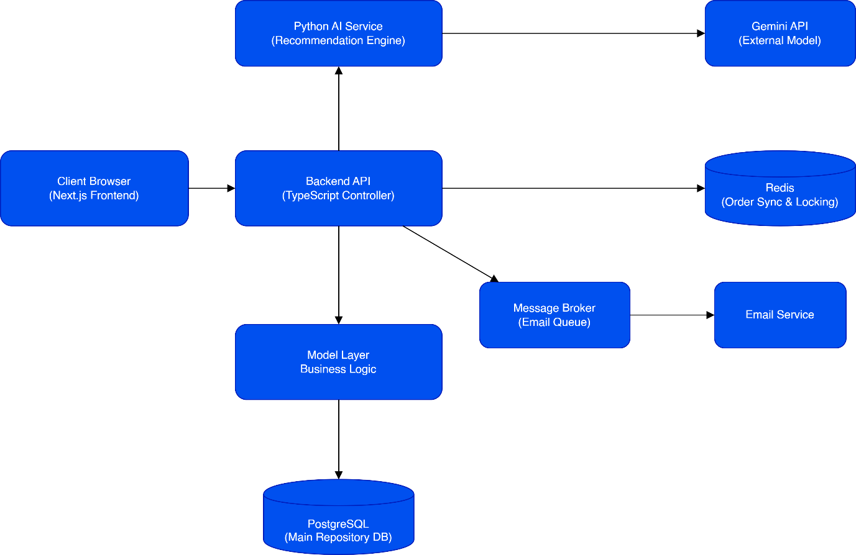
The Hweibo system uses a client–Server architecture combined with the MVC (Model–View–Controller) pattern. This approach separates user interaction from system processing, supports scalable web applications, and allows modular and independent service development.
Architectural Design Diagram

4.1.2 High-Level Architectural Structure

4.1.2.1 Presentation Layer (View)
The Presentation Layer consists of the Next.js frontend running in the client browser. It displays products and recommendations, handles user interactions such as browsing and checkout, sends API requests to the backend, and renders responses. This layer focuses only on user interface and user interaction.

4.1.2.2 Application Layer (Controller)
The Application Layer contains the TypeScript backend API. It receives and validates client requests, manages authentication and authorization, coordinates order processing, and communicates with the database and external services. This layer controls the system flow and enforces business rules.

4.1.2.3 Business Logic Layer (Model)
The Business Logic Layer handles the core marketplace operations. It validates inventory, calculates commissions and delivery fees, processes orders, and applies system rules. This ensures correct and consistent system behavior.

4.1.2.4 Data Layer (Repository)
The Data Layer includes PostgreSQL and Redis. PostgreSQL stores persistent data such as users, products, orders, sales records, and subscriptions. Redis is used for order synchronization, payment locking, duplicate transaction prevention, and real-time operations. This layer maintains data integrity and transaction reliability.

4.1.2.5 AI Service Layer
The AI Service Layer includes a Python recommendation service and the Gemini API. The Python service receives search prompts from the backend, applies predefined rules, calls the Gemini API, and returns ranked product recommendations. The Gemini API performs semantic analysis and generates recommendation explanations. This separation allows the AI component to scale independently.

4.1.2.6 Messaging Layer (Asynchronous Processing)
The Messaging Layer uses a message broker (email queue) for background processing. It handles notifications without blocking checkout operations. The Email Service sends order confirmations, seller notifications, and subscription alerts. This improves system responsiveness and reliability.

4.1.3 Architectural Benefits
This architecture ensures clear separation of concerns, supports scalability and independent deployment of services, improves transaction reliability using Redis locking, enables AI-powered recommendations without affecting core system stability, supports asynchronous communication for better performance, and maintains secure structured data storage with PostgreSQL.

4.2 User Interface (UI)

4.2.1 Onboarding UI (Registration Forms)
On these pages, the user can pick their account type (Seller or Basic Customer) and the sellers can pick pricing plans for special service packages, offered by the platform.
Sign Up page, user can select the account type they want, before being able to use the service.

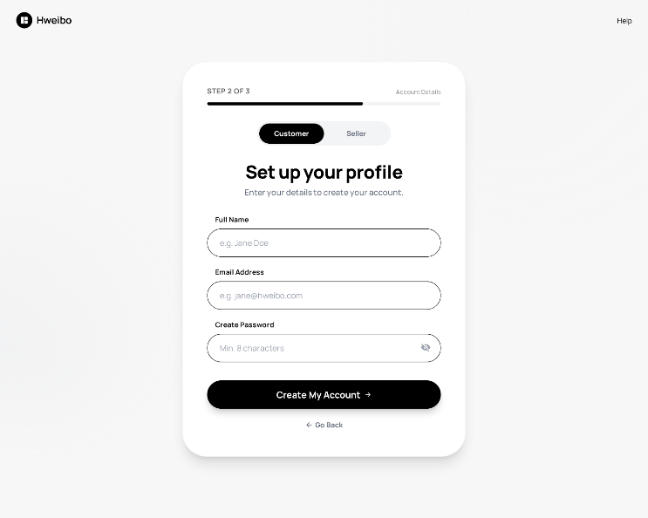
If the user picks, customer they fill a simple form, to fill in their details.

If the user picks to be a seller, they fill in the following form to register their accounts.

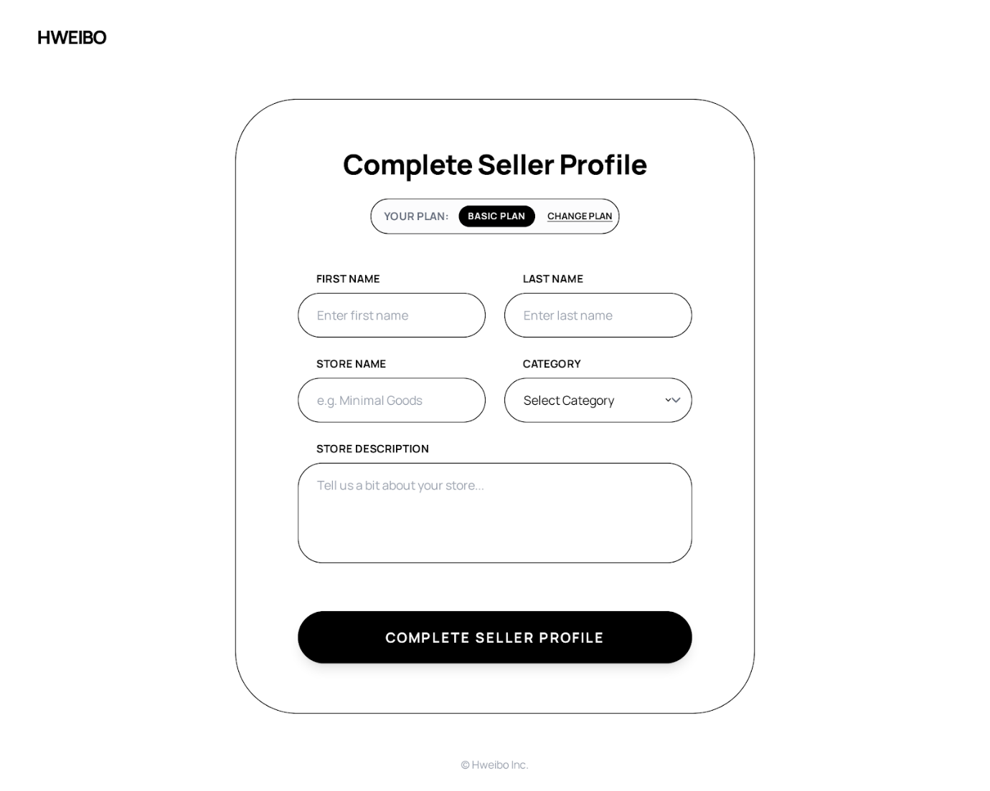

Sellers also can pick the service package; they would like to use on our platform to help boost visibility and sales performance.
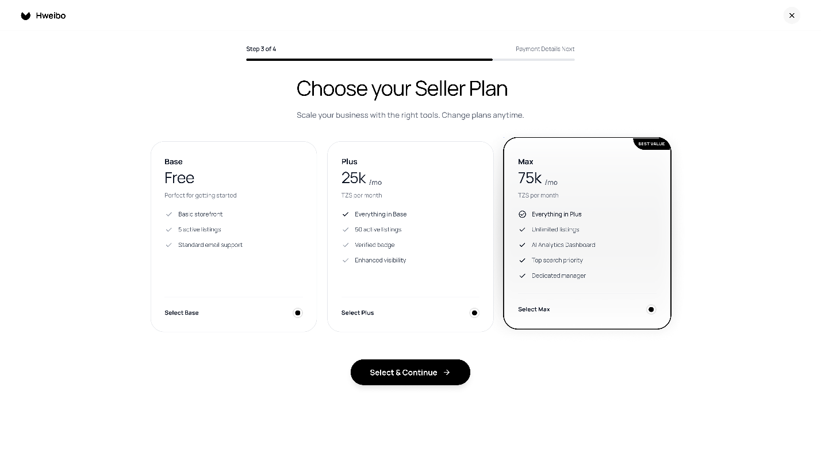

4.2.2 Landing Page
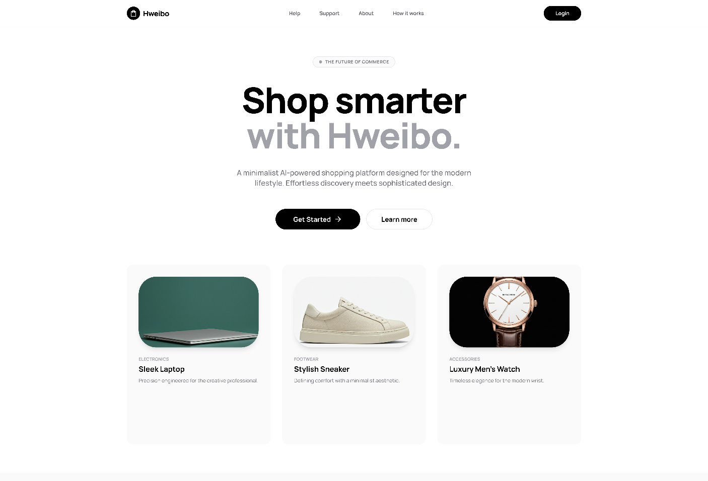
Below is the landing page for the Hweibo Application. It serves to show brief description of what the Web Application does. It helps the customer to get useful information about the system, and makes it easier for them to navigate and understand the Web Application.

4.2.3 Search Page
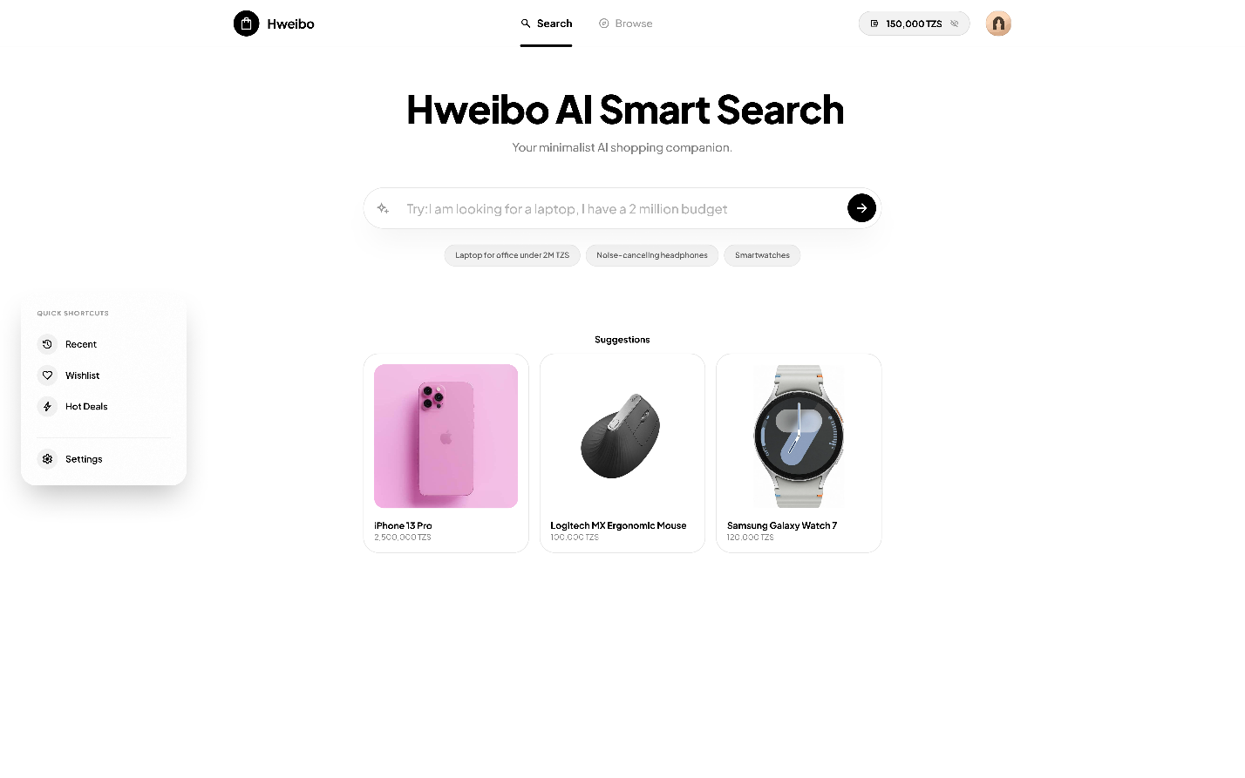
This is the search section where the user can search for the products they are looking for. The user starts by writing a prompt of what they are looking for and the bot proceeds to ask the user several questions to get the right product fit for the user.

4.2.4 Search Results UI
Below is the UI, after the user has prompted the AI to get to the products they want. The user can then pick to compare from the list of the products suggested. Or they can pick a single product and proceed to checkout. By default, the model only returns 5 products maximum to prevent information overhead and the user fails to pick products from being overloaded with options.
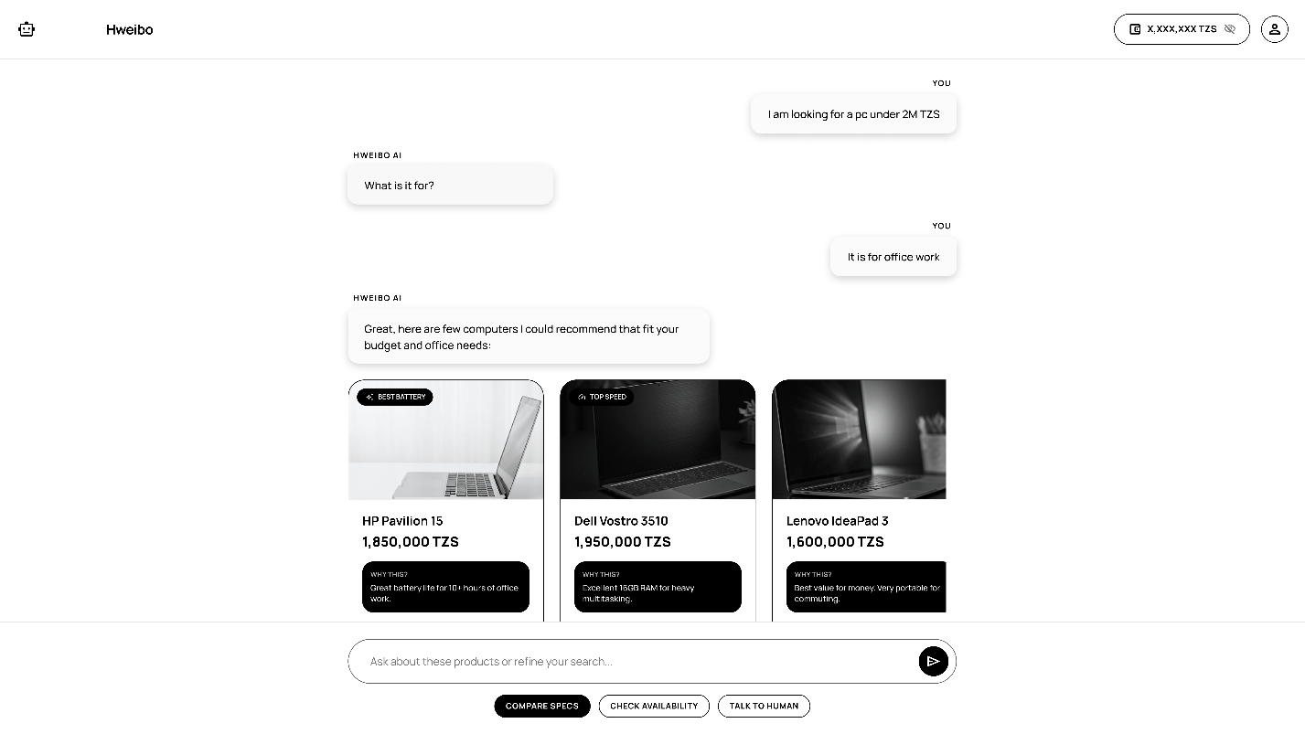

4.2.5 Checkout UI
This is the UI for the user to checkout and finalize their purchase. If the product has delivery available, they’ll pay an extra fee for transporting the product to their desired location. They can pay directly from their wallets (where they top-up their wallets by making deposits and spend it on their products) or they can checkout directly from their Mobile Accounts or their Bank Accounts.

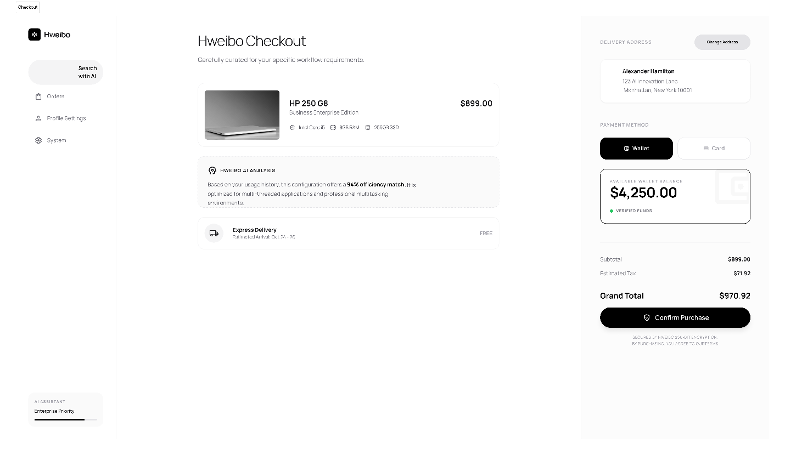

4.2.6 Account UI
This is the UI for the user to view basic profile details and make changes. They can also keep track of their orders. And can also see their balanced or deposits made to their account.

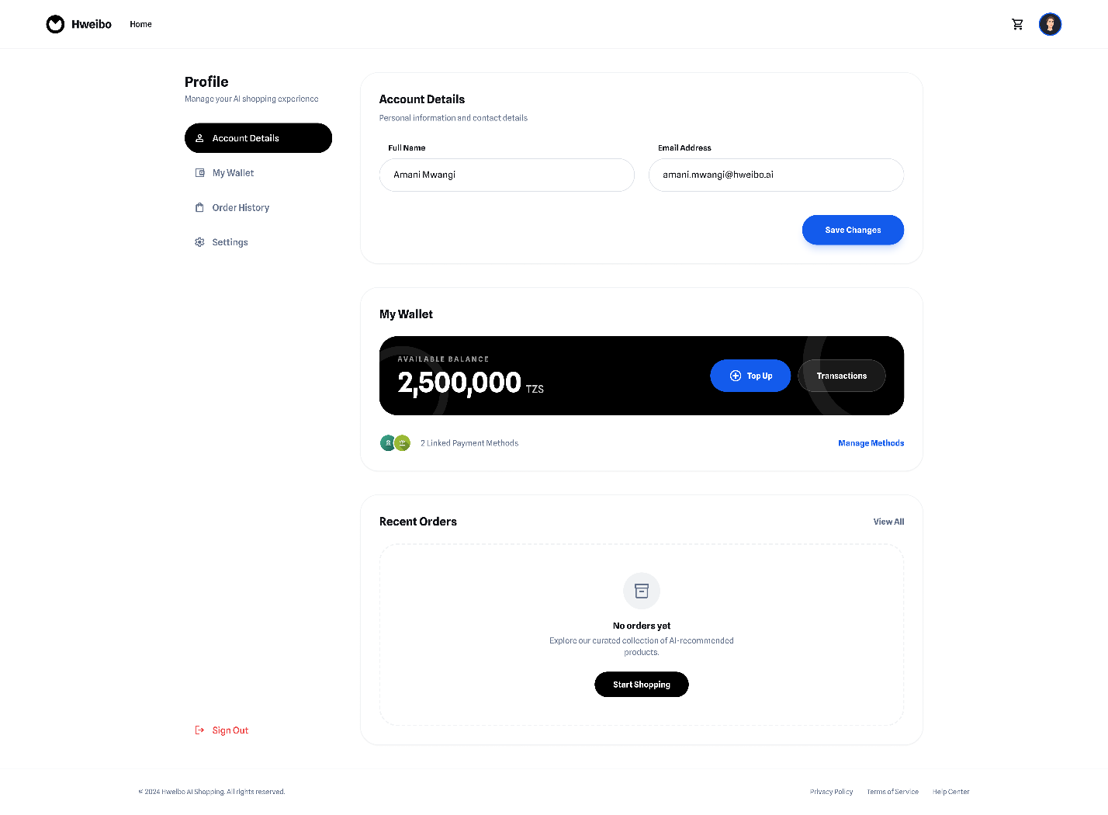

4.2.7 Seller Dashboard UI
This is the UI for the store seller where the user can track all their sales and orders, and see which products are performing well in the market.

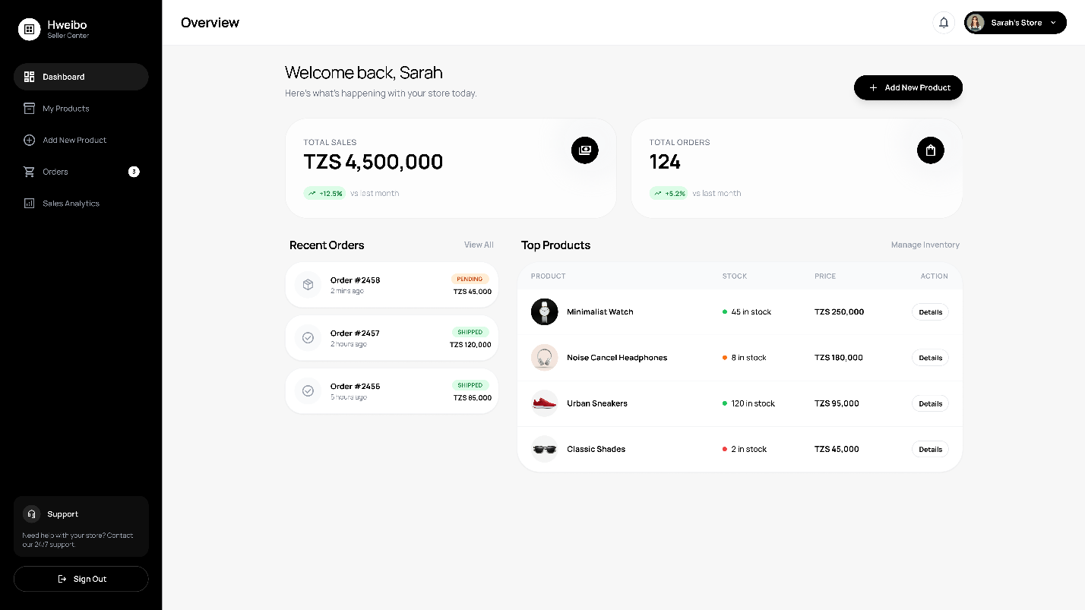

CHAPTER 5: SYSTEM DEVELOPMENT RESULTS AND DEMONSTRATION

System Demonstration
- The user begins by selecting their account type (Seller or Buyer), each user type has specific forms for the user type to fill in to create their account.

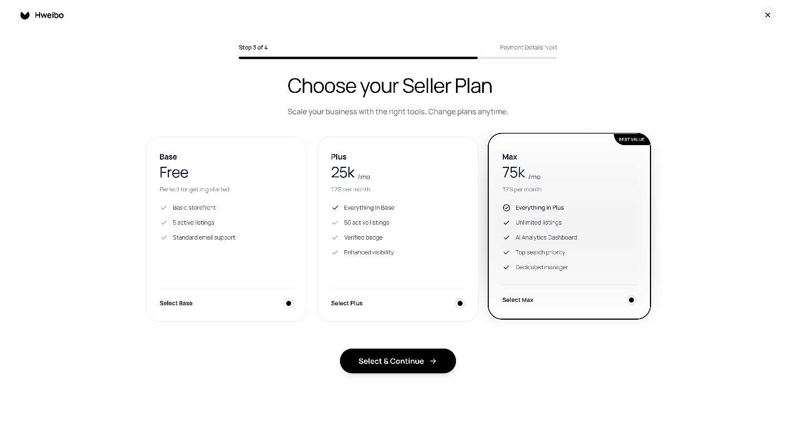
- The Buyer proceeds to register their account with details to help track their accounts. For the seller.

- The users can prompt the AI bot to get what they want, where the bot will ask them a series of questions to help find the best product that matches the user’s demands or wants.
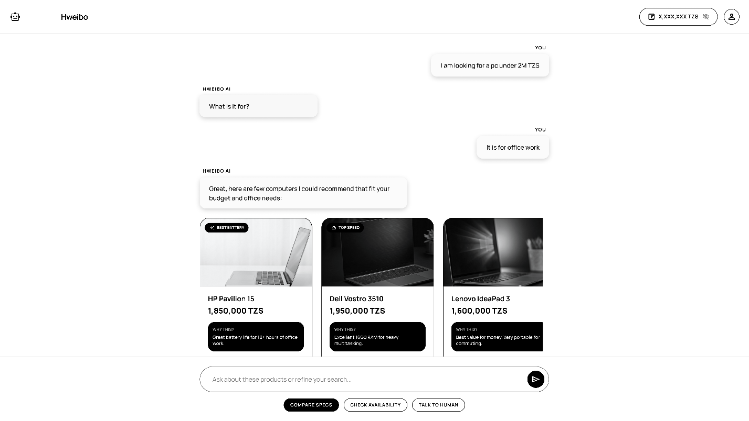

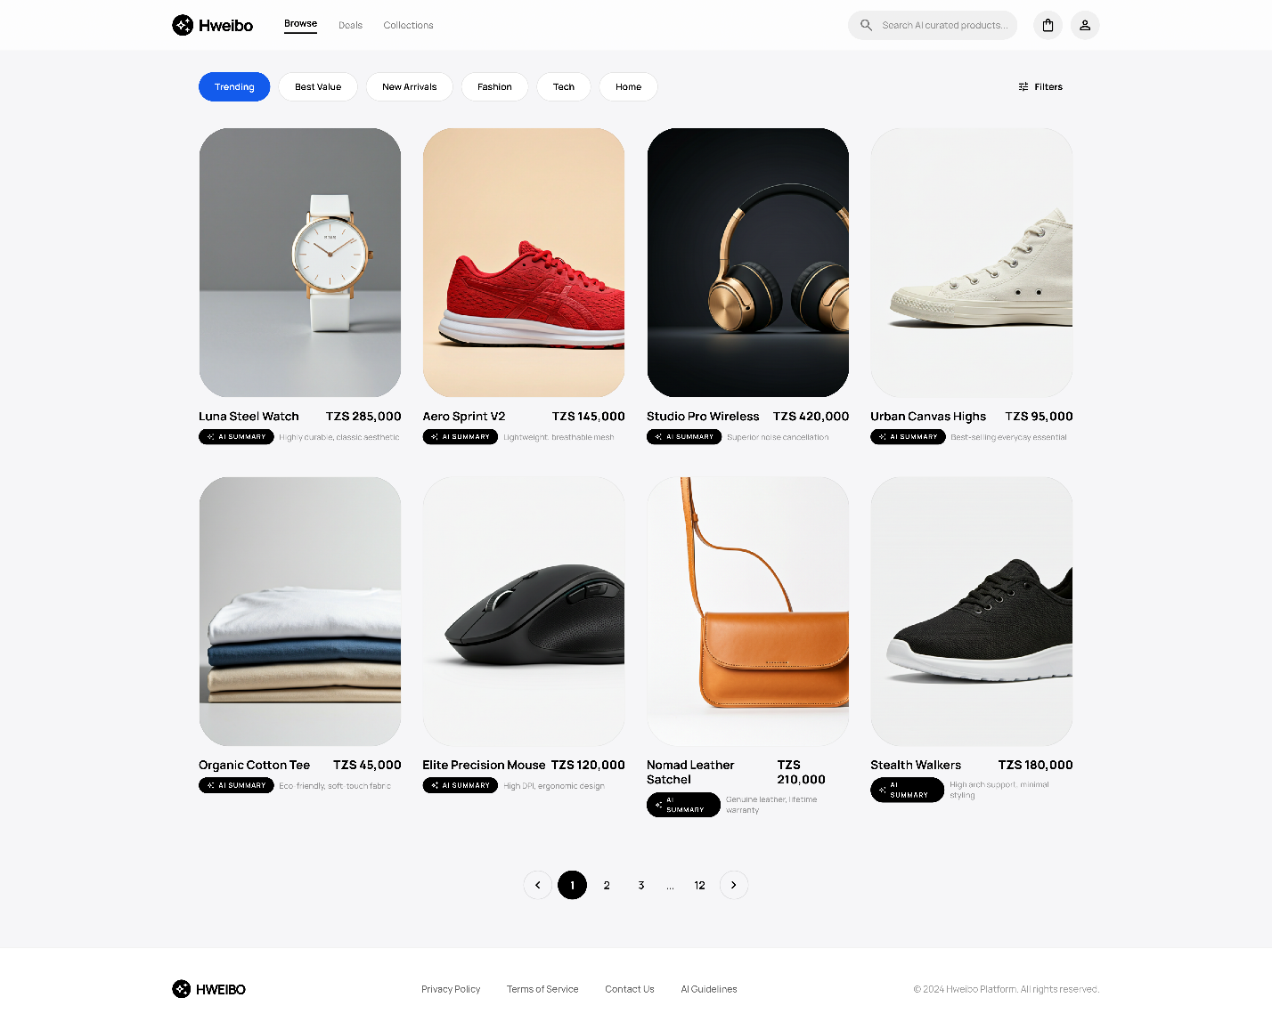
- The user can alternatively browser the market for available goods or product and pick the products they want to purchase and pick favorite products to help improve future AI recommendations.

- After product selection the user can check the details of the product and proceed to checkout to make payments for the product they’ve chosen.

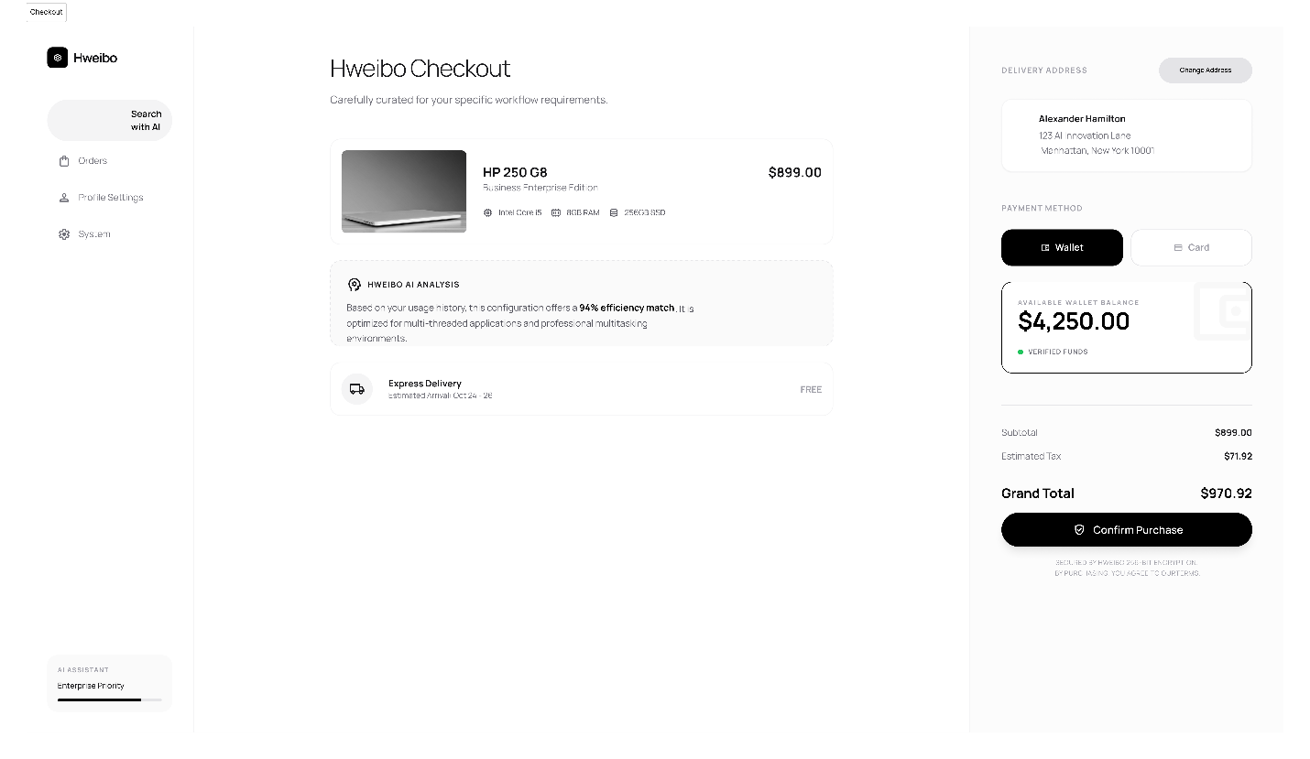

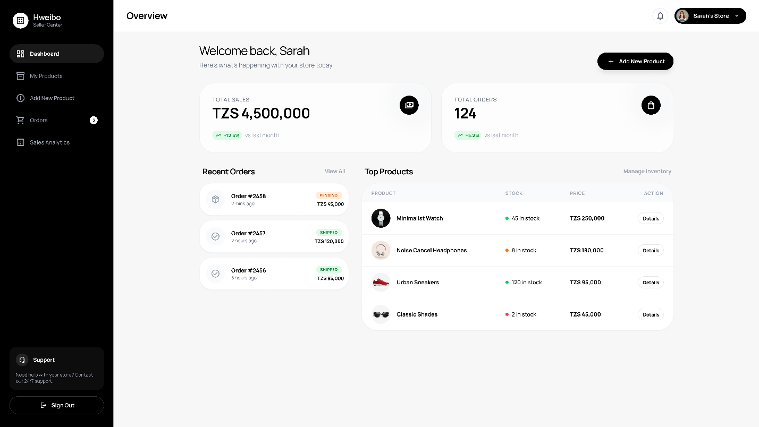
- The seller can keep track of their records of their store and add products or categories.

